CHAPTER I
INTRODUCTION
Problem Background
The Sangguniang Kabataan (SK) plays a crucial role in youth development and community governance, requiring the efficient management of a large volume of official documents such as resolutions, activity proposals, accomplishment reports, minutes of the meetings, document budgets, and approvals. These documents are essential for operational continuity, transparency, and accountability. However, the SK of Ormoc City currently relies heavily on traditional physical file archiving, which has become a significant operational bottleneck.
Based on initial observations and interviews with SK officials, including the SK Secretary, most SK records are stored in physical folders, filing cabinets, and boxes. This manual system exposes documents to several risks and inefficiencies. Physical files are vulnerable to environmental degradation, such as moisture, pests, and natural wear and tear, which may result in the loss of historically and legally important records. In addition, the manual retrieval process is time-consuming and prone to human error, making it difficult to locate specific documents needed for decision-making, reporting, or responding to public inquiries.
The scattered and paper-based nature of these records also creates challenges in monitoring both past and ongoing SK activities. Tracking the status of submitted documents, especially those requiring multiple steps and approvals, is inefficient and often leads to delays. These issues were further confirmed during an informal interview with the SK Secretary, who highlighted that the current document submission and approval process slows down operations and affects overall productivity.
Moreover, physical document storage presents security risks, as it offers limited protection against unauthorized access, loss, theft, or deliberate damage. These vulnerabilities compromise the confidentiality and integrity of sensitive SK records, weakening transparency and accountability within the organization.
In addition to document-related challenges, the SK of Ormoc City also lacks a centralized and updated system for monitoring SK member accounts and membership status. At present, information regarding SK members such as whether a member is active, inactive, or has already quit their position is not systematically recorded or easily accessible. This limitation makes it difficult for SK officials to verify member eligibility, monitor participation, and ensure accurate representation during SK activities and decision-making processes.
Collectively, these challenges hinder the SK’s efficiency and responsiveness, diverting valuable time and resources away from implementing youth programs and community projects. In line with national and global trends toward digitization and considering the availability of reliable information technology solutions, a transition to a digital document management and monitoring system is both strategic and necessary.
Therefore, this study, with the SK Chairman of Ormoc City as the client, recognizes the urgent need to modernize the SK’s operations through the implementation of a digital system that supports secure document archiving and centralized SK account management. The proposed system will allow authorized users to view SK accounts, access a list of all SK members, and monitor their current status (active, inactive, or quit). This solution will ensure secure storage, reliable backups, faster retrieval of records, improved monitoring of SK activities, and accurate tracking of membership status. Ultimately, the system will strengthen administrative efficiency, transparency, accountability, and the SK’s capacity to deliver effective public service.
Theoretical Background
The necessity of a structured and systematic approach to record handling was underscored by the challenges presented in the introduction regarding the inefficient administration of documents within the Sangguniang Kabataan (SK). The continued reliance on manual and paper-based processes often leads to difficulties in document organization, retrieval, and monitoring. In response to these issues, this study leads to record Management Theory, which emphasizes the proper control and management of records throughout their lifestyle, including their creation, storage, retrieval, and preservation. The application to this theory supports the development of the proposed system that aims to improved the organization, accessibility, and monitoring of SK records in Ormoc City.
Records Management Theory
Records Management Theory emphasizes the systematic and organized control of records throughout their entire lifecycle beginning from their creation or receipt, continuing through their classification, maintenance, storage, use, and retrieval, and ending with their archival preservation or lawful disposal. The theory is grounded in the principle that records are valuable organizational assets that must be managed properly to ensure accountability, transparency, and operational efficiency. According to the International Organization for Standardization (ISO 15489), effective records management ensures that records remain authentic, reliable, integral, and usable over time. Authenticity guarantees that records are genuine and trustworthy; reliability ensures that the contents accurately reflect transactions or activities; integrity protects records from unauthorized alteration; and usability allows records to be easily located, retrieved, and interpreted when needed.
Records Management Theory highlights that poor records handling leads to inefficiencies, loss of important information, duplication of documents, delayed decision-making, and weakened institutional memory. In traditional manual filing systems, records are vulnerable to risks such as misplacement, physical deterioration, environmental damage, and unauthorized access. As organizations grow and generate increasing volumes of documents, the absence of a structured records management framework creates operational bottlenecks that affect overall performance.
In the context of the Sangguniang Kabataan (SK), records such as resolutions, activity proposals, project plans, accomplishment reports, approvals, financial documents, and correspondence serve as official documentation of youth governance and community initiatives. These records are essential for legal compliance, transparency, auditing, reporting to higher government units, and historical reference. However, reliance on physical storage methods increases the risk of lost documents, slow retrieval processes, and limited accessibility. When documents are not systematically organized, SK officers may encounter difficulties in monitoring project status, preparing reports, or verifying past decisions.
Applying Records Management Theory to this study provides a strong theoretical foundation for the development of SKActHub, a web-based document management and monitoring system. The system embodies the key principles of the theory by digitizing and structuring the management of SK records. Through digital classification, indexing, tagging, and categorization, SKActHub ensures that documents are logically organized and easily retrievable. The integration of secure storage mechanisms, controlled user access, and backup features helps preserve record integrity and authenticity while minimizing risks associated with physical filing systems.
Furthermore, Records Management Theory emphasizes the importance of lifecycle control. SKActHub supports this by allowing documents to move systematically from creation and submission to review, approval, storage, monitoring, and eventual archiving. Instead of scattered and disconnected paper-based processes, the system centralizes records into a unified platform where status tracking and monitoring become more efficient. This structured lifecycle management ensures that documents are not only stored but actively managed as organizational assets.
The theory also supports accountability and transparency in governance. Proper records management strengthens institutional credibility by providing accurate and accessible documentation of decisions and activities. For the SK, this means improved reporting to the Local Government Unit (LGU), better documentation of youth programs, and enhanced readiness for audits or evaluations. By implementing SKActHub, the organization aligns its document practices with internationally recognized records management standards, promoting professionalism and good governance.
In addition, digital records management enhances continuity of operations. In cases of leadership transition within the SK, well-preserved digital records ensure that incoming officers can easily access past documents, project histories, and reports. This prevents loss of institutional knowledge and supports sustainable governance practices. The availability of searchable and organized digital archives significantly reduces time spent locating documents and improves administrative efficiency.

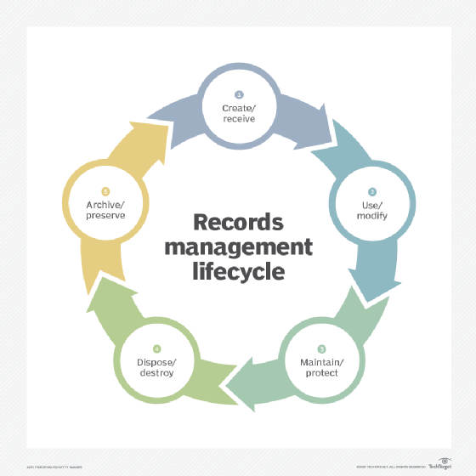
Figure 1: Record Management Theory
Figure 1 illustrates the Record Management Theory applied in the proposed system. It shows how data is collected, organized, stored, and retrieved efficiently to ensure accuracy, security, and accessibility. Inputs such as personnel records, event logs, and user interactions are processed through validation, authentication, and classification, producing outputs like confirmed records, secure access, notifications, and analytical insights for decision-making and accountability.
Conceptual Framework
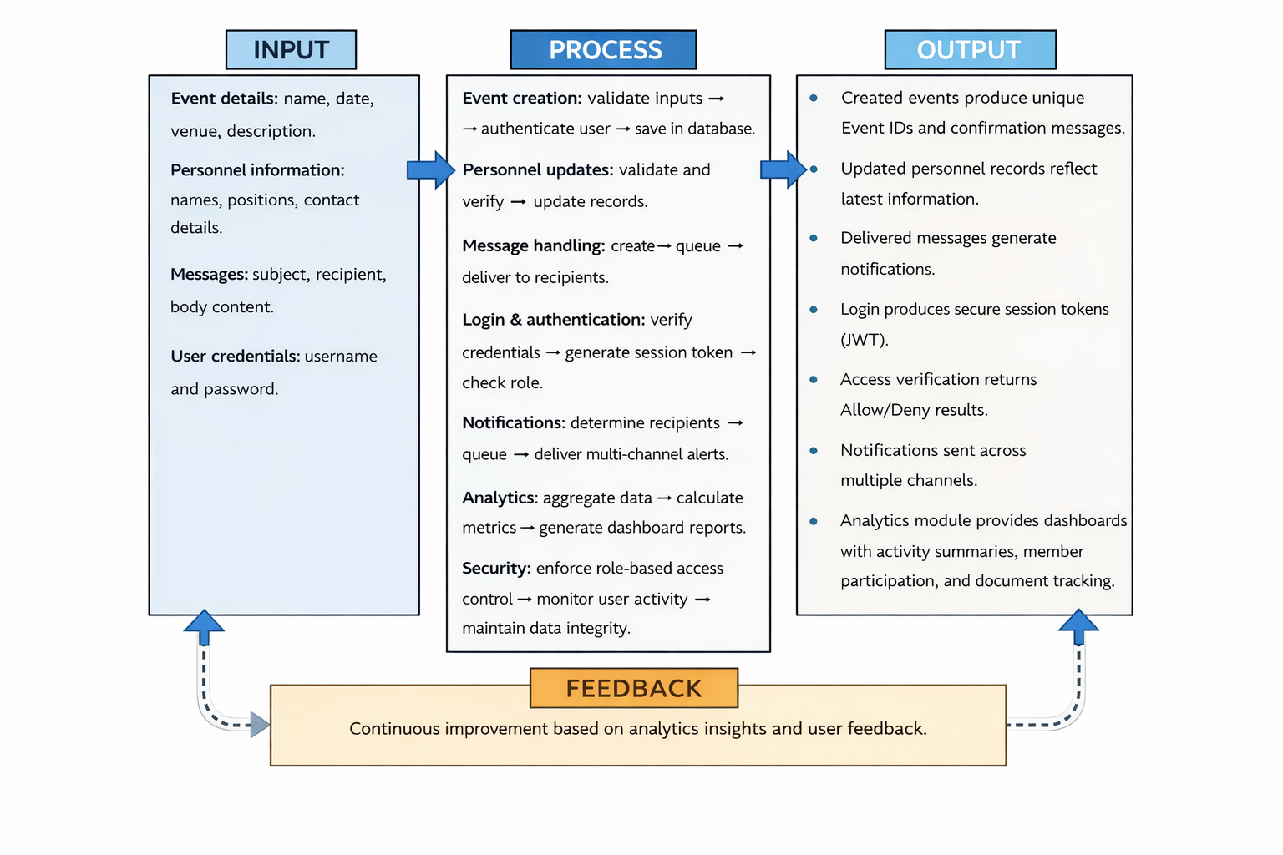
his framework demonstrates how the system transforms manual, paper-based operations into a centralized, automated, and secure digital environment. It emphasizes the flow of information from user-provided data and system interactions to processed outputs ensuring transparency, accountability, and operational efficiency within the Sangguniang Kabataan offices of selected barangays in Ormoc City.
Figure 2 : Conceptual Framework
Figure 2 Presents the Input–Process–Output (IPO) model of the proposed SKActHub system. The input consists of event data, personnel records, user credentials, and system interactions. These inputs undergo validation, authentication, processing, and security enforcement. The output includes confirmed records, secure sessions, notifications, and analytical dashboards that support transparency, accountability, and efficient decision-making.
Statement of the Problem
The Sangguniang Kabataan (SK) plays a key role in youth governance and community program implementation. Efficient management of documents and member records is essential for transparency, accountability, and operational efficiency. Currently, many SK offices in Ormoc City rely on manual, paper-based systems, which often lead to lost or misplaced documents, delayed retrieval, duplication, limited accessibility, and difficulty tracking the status of submitted activities and proposals. The absence of a centralized system hinders proper monitoring, prevents real-time updates, and increases the risk of errors.
Given these challenges, this study seeks to answer the following questions:
- What web-based system can be designed to organize, store, archive, and manage SK documents and SK member information efficiently?
- What features are necessary to enable easy uploading, categorizing, searching, and retrieval of SK documents?
- How can the system track submitted, reviewed, and approved SK activity records to improve workflow monitoring?
- How can a centralized SK account management module help authorized users monitor SK member status (active, inactive, or quit)?
- What security mechanisms, such as user authentication and role-based access control, are required to protect SK documents and member records?
- How effective is the developed system in improving document organization, accessibility, monitoring, security, and overall user convenience for SK officials?
Objectives of the Study
Project Goal
The main goal of this project is to design and develop SKActHub, a Digital Document Management, Archiving, and SK Account Management System to enhance the efficiency, security, accessibility, and monitoring of official documents and SK member records for the Sangguniang Kabataan of Ormoc City.
Specific Objectives
To achieve this goal, the study pursues the following objectives:
- To design a web-based digital system for organizing, storing, archiving, and managing SK documents and SK member information.
- To develop system features that enable easy uploading, categorizing, searching, and retrieval of SK documents.
- To implement a document tracking and monitoring mechanism for submitted, reviewed, and approved SK activity records.
- To develop a centralized SK account management module that allows authorized users to view all SK members and monitor their membership status (active, inactive, or quit).
- To incorporate security mechanisms such as user authentication, role-based access control, and data protection measures to safeguard documents and SK member records.
- To evaluate the effectiveness of the developed system based on usability, efficiency, security, accessibility, and accuracy in managing documents and SK member status.
Significance of the Study
For the Sangguniang Kabataan (SK) Officials of Ormoc City
The proposed Digital Document Management, Archiving, and SK Account Management System (SKActHub) will significantly improve the operational efficiency of SK officials by replacing manual and paper-based filing systems with a centralized digital platform. The system will reduce the time spent searching for misplaced documents, reorganizing physical records, and manually tracking activity submissions and approvals. By automating document storage, classification, and retrieval, SK officials can focus more on planning, implementing, and evaluating youth development programs rather than handling administrative paperwork. Furthermore, the system promotes better workflow management by allowing real-time monitoring of document status and activity progress.
For the SK Chairperson and Administrative Officers
The system will enhance transparency, accountability, and informed decision-making within the organization. With structured document archiving and tracking features, SK leaders can easily verify submitted proposals, review accomplishment reports, and monitor approval processes. The centralized dashboard for SK member accounts will provide updated information regarding membership status (active, inactive, or quit), ensuring accurate representation and compliance with governance policies. This structured monitoring strengthens administrative control and reduces errors caused by manual record-keeping.
For the Barangay Council and Local Government Units (LGUs)
The study contributes to the modernization and digital transformation of local governance processes. By implementing a web-based document and membership management system, barangays and local government units can improve their administrative efficiency and promote transparency in public service. The system may serve as a reference model for other barangays seeking to digitize their records management practices. Additionally, improved document monitoring ensures that records required for audits, reporting, and compliance are properly stored and easily accessible.
For the Youth Development Office (YDO)
The Youth Development Office will benefit from improved access to organized and systematically archived SK activity documents. The system enables easier monitoring and evaluation of youth programs, proposals, and accomplishments submitted by SK officials. With structured digital records, the YDO can more efficiently assess program implementation, ensure compliance with guidelines, and support data-driven decision-making for youth development initiatives.
For SK Members
The centralized SK account management feature ensures that all member records are accurately maintained and regularly updated. Members’ stats whether active, inactive, or resigned can be properly monitored and documented. This reduces confusion regarding membership roles and promotes accountability within the organization. Additionally, improved record management ensures that member information is securely stored and protected from unauthorized access.
For the Community and Residents of Ormoc City
An efficient and transparent SK administration ultimately benefits the youth and residents of the community. When documents, activity reports, and member records are properly managed, the SK can implement programs more effectively and responsibly. Improved administrative processes lead to better service delivery, increased transparency in youth-related projects, and stronger trust between the SK and the community it serves.
For Future Researchers
This study adds to the body of knowledge in the field of digital records management and web-based system development for local government administration. Future researchers may use this study as a reference in designing similar systems for barangays, municipalities, or other public institutions. It may also serve as a foundation for further studies focusing on system enhancement, integration with other government platforms, or long-term digital archiving strategies.
Scope and Delimitations of the Study
This study focuses on the design and development of SKActHub, a web-based Project Management, Document Management, and SK Account Management System intended to support the monitoring and tracking of Sangguniang Kabataan (SK) activities and SK membership information in order to strengthen SK governance for the Ormoc City Youth Development Office.
Scope
The scope of the study covers the design, development, and implementation of SKActHub for the Sangguniang Kabataan of Ormoc City. The system is designed to support the management, archiving, organization, retrieval, and monitoring of SK activity-related documents, including activity proposals, accomplishment reports, approvals, budgets, minutes of meetings, financial reports, resolutions, and other official SK records.
The implementation and testing of the system are limited to the following selected barangays of Ormoc City:
• Barangay South
• Barangay East
• Barangay Ipil
• Barangay Cagbuhangin
• Barangay Don Felipe Larrazabal
These five barangays serve as the primary participants and pilot users of the system for evaluation and validation purposes.
The system includes a centralized SK account and membership management feature, which allows authorized users to view SK accounts, access a list of SK members, and monitor each member’s status (active, inactive, or quit) to support accurate record-keeping and administrative monitoring.
The primary users of the system are the SK Chairmen, who are provided with individual system accounts. The SK Secretary may be granted permission by the SK Chairman to assist in document posting and management, as well as in updating SK member information; however, account ownership and overall system control remain with the SK Chairman.
SKActHub focuses on document posting, project and activity monitoring, SK account viewing, and membership status tracking. The system allows authorized users to upload, store, organize, retrieve, and monitor documents related to SK activities such as activity proposals, accomplishment reports, budgets, minutes of meetings, financial statements, resolutions, and other administrative documents while maintaining updated records of SK members. It supports improved monitoring of submitted documents, completed activities, and SK member participation.
The system is developed as a web-based application using the MERN stack (MongoDB, Express.js, React.js, and Node.js) based on the developers’ knowledge and technical expertise. Due to its web-based nature, the system is intended for use through a web browser and requires a desktop or laptop computer with a stable internet connection.
Delimitations
This study is limited to the development and implementation of SKActHub for the Sangguniang Kabataan of Ormoc City, specifically involving five selected barangays: Barangay South, Barangay East, Barangay Ipil, Barangay Cagbuhangin, and Barangay Don Felipe Larrazabal. It does not cover all SK offices in Ormoc City due to time constraints and the defined scope of the project.
SKActHub is developed as a desktop-based web application, which means it is intended for use on laptops or desktop computers through a web browser and is not optimized for mobile devices. User access is restricted primarily to SK Chairmen, while SK Secretaries may be granted limited access for assistance in document posting and updating membership records. Other SK officials, youth members, or residents of the community do not have direct access to the system, ensuring data security and controlled management.
The system focuses on document handling, activity monitoring, and SK member status tracking. It does not include advanced features such as automated approval workflows, financial tracking, attendance monitoring, role assignment, performance evaluation, offline access, real-time analytics, or integration with other government information systems. The system is intentionally designed to prioritize essential functionalities for efficient record-keeping and operational monitoring rather than enterprise-level automation.
Definition of Terms
- SKActHub
Technical: A web-based Project Management, Document Management, and SK Account Management System developed using the MERN stack to provide centralized storage, organization, monitoring, and retrieval of SK activity documents and membership records
.Operational: A digital platform utilized by SK officials in selected barangays to upload, organize, monitor, and manage activity proposals, accomplishment reports, and member information efficiently.

- Sangguniang Kabataan (SK)
Technical: The officially recognized youth council established in every barangay with a defined organizational structure responsible for planning, implementing, and documenting youth-related programs and activities.
Operational: The SK offices in selected barangays of Ormoc City that use SKActHub to manage documents and monitor youth membership records.
- SK Chairman
Technical: The duly elected head of the SK with administrative privileges and full access rights within SKActHub, including document and membership record management
Operational: The primary user of SKActHub in each barangay who uploads documents, monitors activities, manages membership status, and controls access permissions.
- SK Secretary
Technical: An appointed SK official granted restricted system access privileges by the SK Chairman to assist in documentation and record management.
Operational: A secondary user of SKActHub who supports the SK Chairman by uploading documents, updating member information, and maintaining activity records.
- SK Treasurer
Technical: An appointed SK official granted restricted system access privileges by the SK Chairman to assist in financial documentation and record management.
Operational: A secondary user of SKActHub who supports the SK Chairman by managing financial records, uploading financial documents, and maintaining budget and expense reports related to SK activities.
- SK Account
Technical: A system-generated user credential assigned to authorized SK officials with role-based permissions for secure system access.
Operational: The personal login account used by SK officials to access SKActHub and perform assigned administrative tasks.
- SK Member
Technical: An individual officially registered in SKActHub with a unique membership profile containing personal and participation-related data fields.
Operational: A youth participant whose membership details and activity status are digitally recorded and monitored in the system.
- Membership Status
Technical: A system-defined classification indicating a member’s current standing (active, inactive, or quit) within the SK database.
Operational: The designation used by SK officials to track member participation and eligibility in programs and activities.
- Activity Proposal
Technical: A structured digital document stored in SKActHub that outlines the objectives, scope, timeline, and expected outcomes of a proposed SK project.
Operational: A proposal prepared and submitted by the SK to document planned youth programs or events for monitoring and reference.
- Accomplishment Report
Technical: A system-recorded document detailing the implementation process, outputs, and outcomes of completed SK activities.
Operational: A report used by SK officials to document completed programs and evaluate activity performance.
- Document Management System (DMS)
Technical: A software component designed to securely organize, store, retrieve, and manage electronic documents within a centralized database environment.
Operational: The feature within SKActHub that enables SK officials to manage and access digital documents efficiently.
- Role-Based Access Control (RBAC)
Technical: A security mechanism that restricts system access and permissions based on predefined user roles to ensure data integrity and confidentiality. Through role-based access control, the SK Chairman has full visibility of all documents stored in the system, while the SK Secretary and SK Treasurer can only view and manage the documents they have uploaded or the folders they have created.
Operational: A system feature that allows the SK Chairman to assign and manage access privileges of the SK Secretary and SK Treasurer within SKActHub. The Chairman can monitor and access all uploaded documents, whereas the Secretary and Treasurer are limited to viewing and managing only the documents they submitted or the folders they created.
- Web-Based Application
Technical: A software application that operates through a web browser over an internet connection, enabling centralized data processing and remote accessibility.
Operational: The interface of SKActHub accessed via desktop or laptop devices where users perform document management and monitoring tasks.
- MERN Stack
Technical: A full-stack web development framework composed of MongoDB, Express.js, React.js, and Node.js used for database management, server-side processing, and front-end development.
Operational: The technological foundation of SKActHub that enables data storage, system processing, and interactive dashboard functionality.
- Document Monitoring
Technical: The systematic tracking of document submission, status updates, revisions, and completion within a digital management system.
Operational: The process used by SK officials to ensure that proposals and reports are properly recorded, updated, and accessible.

CHAPTER II

Review of Related Literature and Studies

Effective document management and activity monitoring are essential for transparency, accountability, and operational efficiency in institutions such as the Sangguniang Kabataan (SK). Proper record-keeping provides documented evidence of programs, financial transactions, and official activities that support informed decision-making and public trust. However, many SK offices still rely on paper-based filing systems, which often lead to misplaced documents, delayed retrieval, duplication, and limited accessibility. These manual processes also increase the risk of errors and damage to records, making activity monitoring less efficient.
Studies show that digital document management systems significantly improve record organization, security, and accessibility. Centralized platforms enable faster document retrieval, better classification, and secure storage of files. Features such as automated tracking and role-based access control also enhance transparency and ensure that only authorized personnel can access sensitive information. Despite these advantages, limited studies focus on integrated systems specifically designed for SK operations, highlighting the need for a platform that combines document management and activity monitoring to improve administrative efficiency.

Local Studies
Digital Document Management Systems
Dizon and Cruz (2023) developed a blockchain-based barangay document management system integrated with Optical Character Recognition (OCR) technology in a Philippine local government office. The study included 50 barangay staff members who utilized the system for six months. Their findings revealed that automation reduced manual encoding errors by 40%, accelerated document processing by 30%, and improved record immutability through blockchain technology, preventing unauthorized alterations. The study emphasizes that the integration of emerging technologies enhances public trust, transparency, and data integrity within local government operations, supporting the rationale for SKActHub’s secure storage design.
Similarly, Innovatus Research Group (2019) implemented a web-based document management system in a barangay office in Leyte. Using pre- and post-implementation assessments, they found notable improvements in document classification, retrieval speed, and inter-office coordination. Document retrieval time was reduced from an average of 30 minutes under a paper-based system to under 5 minutes with the digital system. The study highlights that digital repositories reduce physical storage dependency and improve administrative efficiency, directly supporting SKActHub’s document storage and organization functionality.
Reyes et al. (2021) studied cloud-based document archiving in municipal offices and reported enhanced compliance with record-keeping policies, reduced document misplacement by 65%, and faster access to records. The study reinforces the importance of centralized document repositories, which SKActHub provides for SK activity proposals, accomplishment reports, and membership data.
Document Tracking and Workflow Monitoring
Bautista et al. (2022) developed a web-based document tracking system for a Philippine institutional setting involving 75 employees over six months. The system allowed real-time monitoring of documents from submission to approval, incorporating automated status updates, email and SMS notifications, and visual tracking dashboards. The study reported a 35% reduction in processing delays, improved coordination among departments, and faster completion of multi-step approval workflows. These findings support the inclusion of SKActHub’s automated status updates and notification modules to improve the efficiency of SK document handling.
Similarly, Lopez and Mendoza (2023) implemented a barangay request and tracking system in Leyte, designed to minimize human errors, generate automated performance indicators, and enhance transparency. Their evaluation indicated that the system increased accountability as each document could be traced from submission to completion, reducing misplaced files and confusion during approval.
Santos et al. (2021) examined workflow monitoring in several Philippine municipal offices. Their research indicated that real-time dashboards and automated alerts facilitated faster decision-making, improved compliance with reporting timelines, and allowed administrators to detect bottlenecks in activities. These studies collectively validate SKActHub’s inclusion of document tracking and workflow monitoring as essential components for operational transparency and administrative efficiency.
User Acceptance and System Usability
Garcia et al. (2022) assessed the Docu-Go system in the Philippines, focusing on user experience and usability. The study reported that an intuitive interface, structured navigation, and role-based access control significantly enhanced user confidence, reduced errors, and increased productivity. This underscores the need for SKActHub to provide a user-friendly interface with clear navigation paths to encourage adoption and minimize operational errors.
Local Literature
Digital Governance and System Adoption
Reyes and Dela Cruz (2020) explored digital governance in Philippine municipalities and found that digitized processes minimized document misplacement, streamlined administrative workflows, and improved public service delivery. The study noted that increased transparency led to higher citizen trust, as verifiable records and auditable transactions replaced traditional paper-based processes.
Velasco (2021) studied municipal e-governance adoption and emphasized that organizational readiness, robust IT infrastructure, and staff training were critical success factors. Municipalities that implemented structured onboarding programs, ongoing technical support, and periodic performance evaluations achieved higher adoption rates, demonstrating that effective implementation strategies are as important as the system itself. These insights are directly applicable to SKActHub, highlighting the need for user training and continuous support to ensure smooth adoption in SK offices.
Foreign Studies
Digital Document Management Systems
and Fianty (2023) investigated web-based document management systems in multiple Southeast Asian municipalities, involving 100 administrative users. Their study highlighted that centralized storage, workflow automation, and role-based access control significantly improved operational efficiency and interdepartmental collaboration. Audit trail features enabled supervisors to monitor document modifications, access history, and user activities, which increased transparency and minimized disputes between departments. The researchers also emphasized that digital systems reduced redundancies caused by duplicate records and improved reporting accuracy by providing real-time updates on the status of requests and documents. These findings demonstrate that integrating workflow automation and role-based permissions can enhance accountability, a feature directly relevant to SKActHub’s design.
Similarly, Smith et al. (2022) conducted a European study on local government digital archives, analyzing the effects of digital systems on record retrieval and data security. Their study found that digital archiving reduced document retrieval time by 60% and enhanced compliance with international data security standards, such as GDPR. The system also included version control, which prevented accidental or unauthorized modifications, ensuring document integrity. These findings highlight the importance of secure, centralized storage and automated access control in managing sensitive records.
Document Tracking and Workflow Monitoring
Awang Gani et al. (2024) investigated electronic document management systems in Malaysian government agencies. Their study highlighted that workflow monitoring strengthened compliance with institutional procedures, reduced the risk of lost documents, and improved audit readiness. The system’s automated logging mechanisms provided verifiable trails for all activities, ensuring accountability and simplifying audits.
O’Connor and Lee (2022) studied digital workflow systems in Canadian municipal offices, observing that integrated dashboards and alerts facilitated task tracking, improved coordination across departments, and enabled administrators to detect and resolve process delays early.
User Acceptance and System Usability
Triyana and Fianty (2023) applied the Technology Acceptance Model (TAM) to web-based document management systems. Their research revealed that perceived usefulness and ease of use were the primary determinants of adoption. Training programs and structured onboarding reduced resistance to change and facilitated smoother transitions from manual to digital processes.
Foreign Literature
Digital Governance and System Adoption
Bizi, Ghazali, and Yunus (2025) examined e-record adoption in Indonesian public institutions. Their findings underscored the importance of leadership support, technological readiness, and staff competence in successful digital system implementation. Institutions that invested in training and infrastructure experienced higher efficiency and compliance.
Anonymous (2025) analyzed European digital governance systems and emphasized usability, digital literacy, and structured training programs as crucial for adoption. The study noted that resistance to change and inadequate support are common barriers in implementing digital systems. These findings suggest that SKActHub must integrate a clear implementation roadmap, user-friendly interfaces, and comprehensive training to maximize user acceptance and long-term system sustainability.
CHAPTER III
Methodology
Effective implementation of any technological solution requires a clear and structured research approach. This chapter presents the methodology used in the study, detailing the design, development, and evaluation processes undertaken to create SKActHub. It outlines the research framework, system development strategy, and procedures followed to ensure that the resulting system addresses the operational challenges of the Sangguniang Kabataan in managing documents, monitoring activities, and tracking membership records. By adopting a structured methodology, the study aims to ensure that the developed system is both practical and aligned with the administrative requirements of SK officials in selected barangays of Ormoc City.
Project Design
This study utilized the Developmental Research Method, which focuses on the systematic design, development, implementation, and evaluation of a functional system to address organizational needs. Unlike descriptive research that only examines existing conditions, developmental research emphasizes creating and validating a technological solution that improves operational processes. This method is appropriate for information technology projects because it provides a structured approach to transforming identified problems into a working digital system.
In this study, the method guided the development of SKActHub by identifying issues in manual document handling, activity monitoring, and membership record management within the Sangguniang Kabataan. These concerns served as the basis for defining system objectives, functional requirements, and system design.
The primary objective of the study is to develop SKActHub, a web-based Project Management, Document Management, and SK Account Management System for selected barangays in Ormoc City. The development process included planning, requirements analysis, system design, development, testing, and deployment to ensure the system meets user and operational needs. The system provides secure document storage, organized record management, activity tracking, and centralized membership monitoring. Testing and refinement were conducted to ensure functionality, usability, reliability, and security before implementation.
Development Model
The system development followed the Software Development Life Cycle (SDLC) framework to ensure a structured and organized process. For this study, the Agile Development Model was adopted to allow iterative development, continuous feedback, and incremental system improvement throughout the project.
The Agile model was applied in the following phases:
1. Requirements Gathering and Analysis – We researchers collected system requirements by identifying the needs of SK officials and reviewing existing document management practices in the selected barangays. Information such as required system features, document types, user roles, and activity monitoring needs were identified to guide system development.
2. System Design – Based on the gathered requirements, we researchers designed the system architecture, database structure, user interface layout, and system workflow. This phase included planning the structure of modules such as user accounts, document management, event monitoring, and notification systems.
3. Development (Coding) – The SKActHub system was developed using the MERN stack (MongoDB, Express.js, React.js, and Node.js). System features were implemented gradually, starting with core functionalities such as user authentication, document uploading, and event management, followed by additional modules like notifications and dashboard analytics.
4. Testing – Functional testing and usability testing were conducted to ensure the system operated correctly. Errors and bugs discovered during testing were fixed, and improvements were made based on feedback from potential users.
5. Deployment and Implementation – After testing and refinement, the system was deployed and made accessible to the selected barangays for actual use and evaluation.
6. Maintenance and Refinement – We searchers continuously improved the system by addressing issues encountered during implementation and applying enhancements based on user feedback.

Entity Relationship Diagram (ERD)
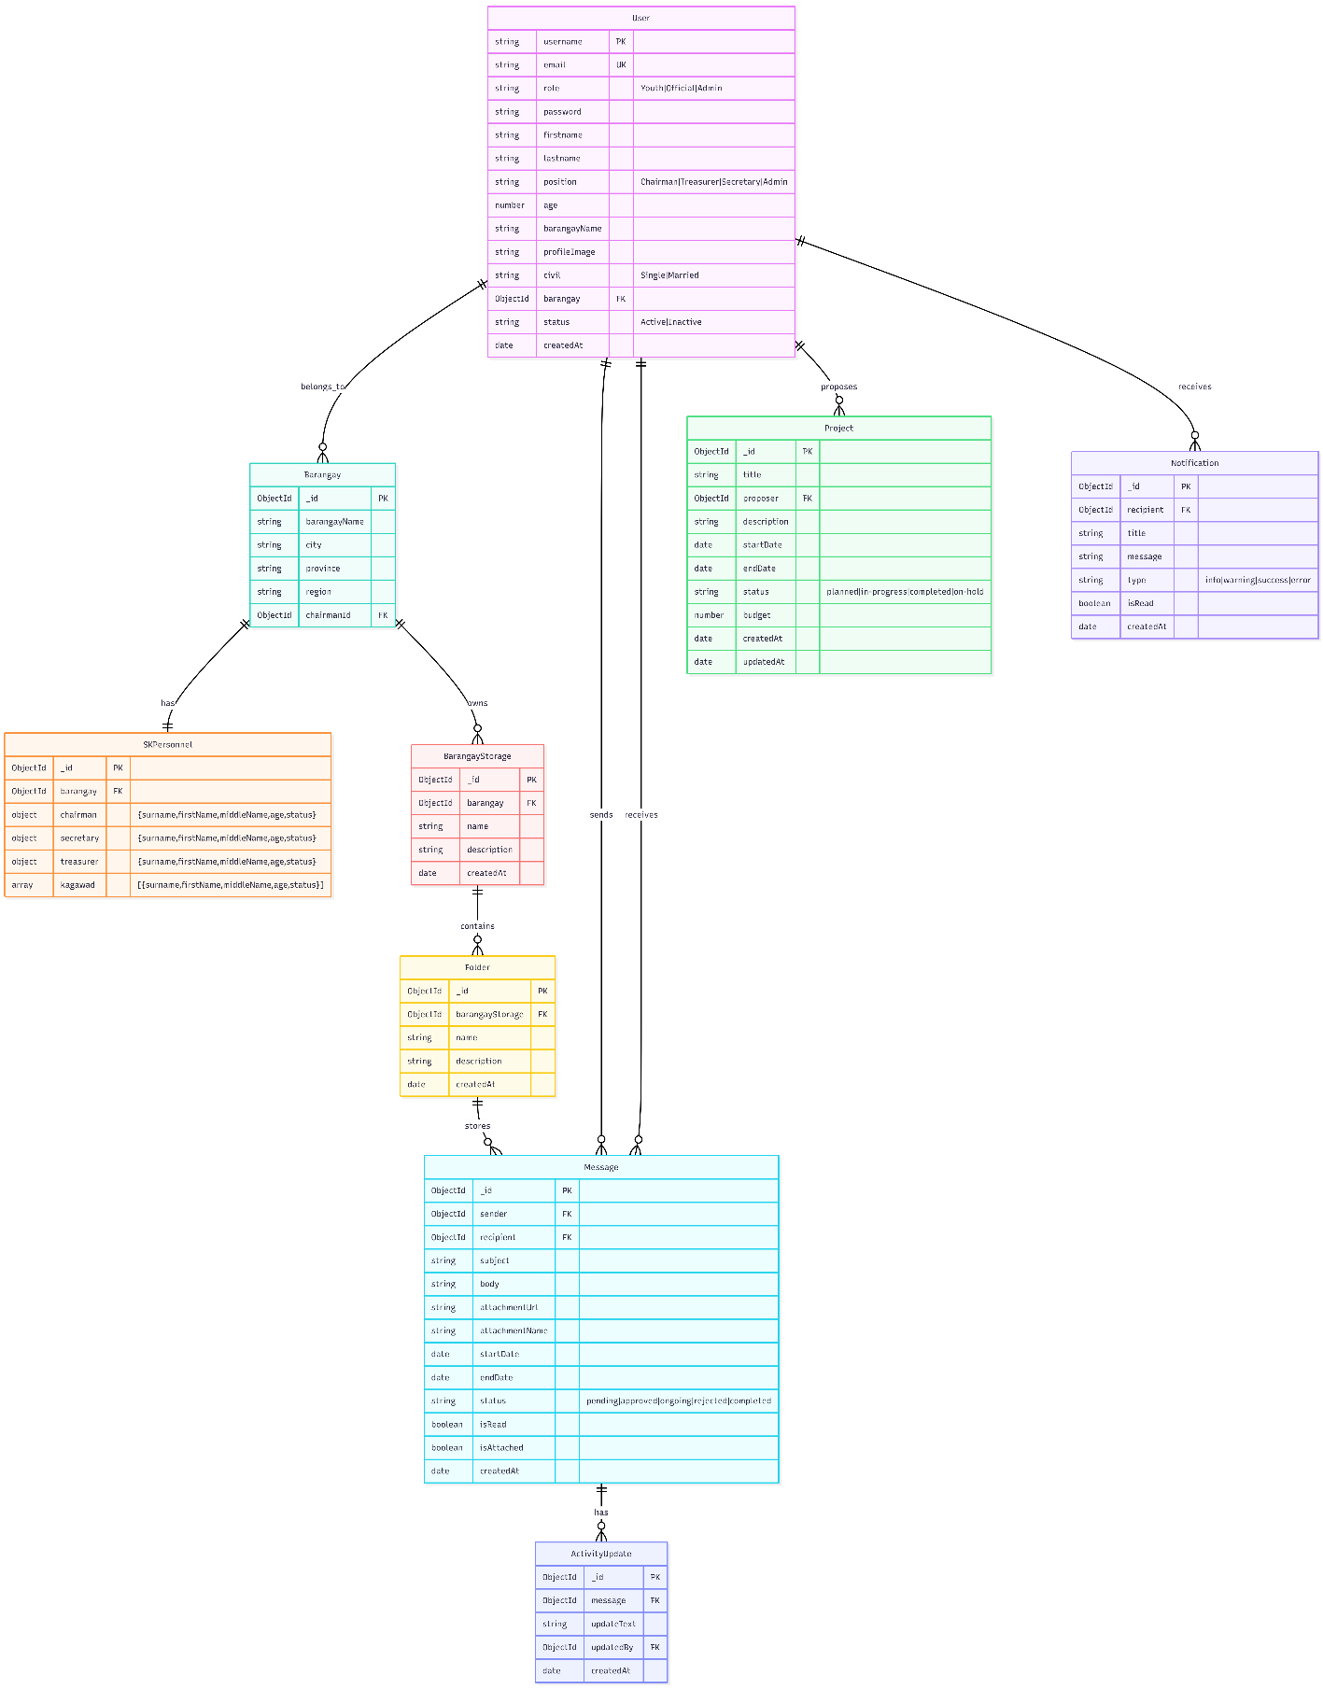

Figure 3: Entity Relationship Diagram
DATA FLOW DIAGRAM
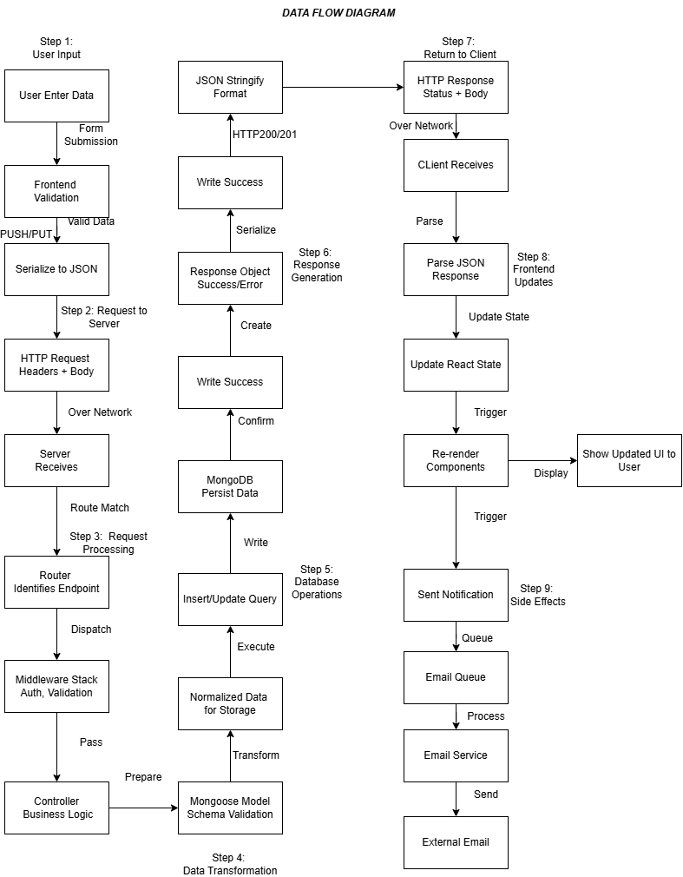
Figure 4: Data flow Diagram

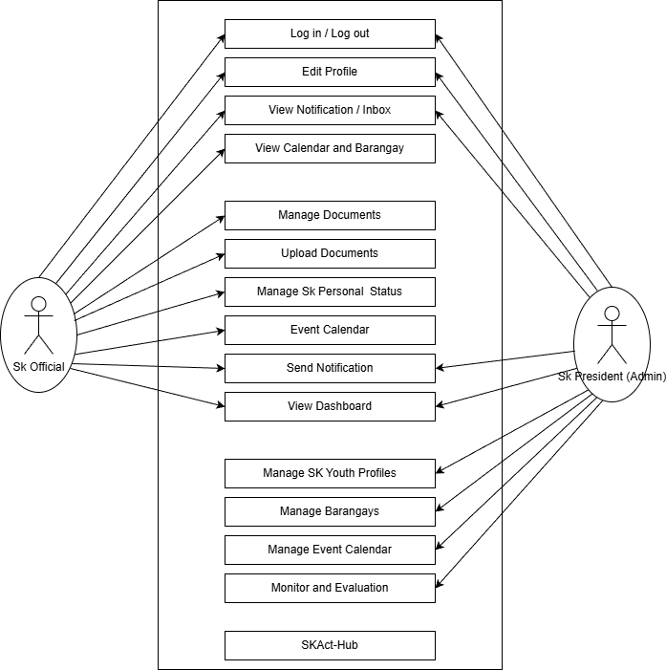
Figure 5: Use Case Diagram
Figure 4 illustrates the interactions between the SK Official and SK President (Admin) with the SKAct-Hub system. It shows the main functions available in the system such as login/logout, managing documents, viewing notifications, event calendar, and dashboard. The diagram also highlights the additional administrative functions of the SK President, including managing youth profiles, barangays, and monitoring activities.

Project Locale

Figure 6 : Project Locale Location
Figure 6 This study was conducted in five (5) selected barangays in Ormoc City, Leyte, Philippines. Ormoc City is a component city located in the western part of Leyte Province in Eastern Visayas. It serves as an important administrative and economic center in the region.
The selected barangays included in this study are:
- South
- East
- Ipil
- Cagbuhangin
- Don Felipe Larrazabal
These barangays were chosen based on their accessibility, availability of active Sangguniang Kabataan (SK) officials, and their current reliance on manual or paper-based document management practices. The study focuses on improving how SK documents and member records are stored, organized, and monitored within these barangays through the implementation of the proposed SKActHub system.
Respondents of the Project
The respondents of the study consist of the official members of the Sangguniang Kabataan (SK) from the five selected barangays, including the following:
• SK Chairpersons (5) – The SK Chairperson serves as the head of the Sangguniang Kabataan in the barangay. The Chairperson is responsible for leading youth programs and activities, presiding over meetings, approving proposals and reports, and ensuring that all SK projects are implemented effectively and in accordance with existing laws and regulations.
• SK Secretaries (5)– The SK Secretary is responsible for managing official records and documentation of the SK. This includes preparing meeting minutes, organizing activity proposals and accomplishment reports, maintaining files and correspondence, and ensuring proper documentation and record-keeping of all SK transactions and activities.
• SK Treasurers (5) – The SK Treasurer is in charge of handling financial records and funds of the SK. Their responsibilities include managing budgets, recording financial transactions, preparing financial reports, and ensuring that all expenditures are properly documented and aligned with approved SK programs and activities.
These respondents were selected because they are directly involved in preparing, submitting, organizing, and monitoring official SK documents and records. Their evaluation is essential in determining the effectiveness, usability, and functionality of the developed system.
Project Description
SKActHub is a web-based system designed to enhance the management of Sangguniang Kabataan (SK) documents, activities, and membership information. The system enables SK officials to efficiently upload, organize, and archive important records such as activity proposals, accomplishment reports, and approval documents in a centralized digital repository. It also provides real-time monitoring of submitted documents and ongoing activities, allowing officials to track progress, identify delays, and ensure timely completion of tasks. In addition, SKActHub includes a membership management feature that allows administrators to maintain and update SK member records, including monitoring membership status such as active, inactive, or resigned members. To ensure data security and confidentiality, the system incorporates role-based access control, restricting access to sensitive information based on user roles and responsibilities. By transitioning from traditional paper-based processes to a structured digital workflow, SKActHub improves transparency, strengthens accountability, and enhances overall operational efficiency within SK offices.

Technology Used
Technology / Tool | Category | Description | Purpose in the System
MongoDB | Database | A NoSQL document-oriented database that stores data in flexible JSON-like structures. | Stores SK documents, member records, activity logs, and system data.
Express.js | Backend Framework | A lightweight web framework for Node.js used for building APIs and server-side applications. | Handles routing, API requests, and server-side logic.
React.js | Frontend Library | A JavaScript library used for building interactive and dynamic user interfaces using reusable components. | Creates dashboards, document upload pages, and monitoring interfaces.
Node.js | Runtime Environment | A server-side JavaScript runtime environment used to execute backend code. | Processes system logic and connects the server to the database and frontend.
JSON Web Token (JWT) | Authentication | A token-based authentication mechanism used for secure login and session management. | Secures user authentication and protects system access.
Tailwind CSS | UI Framework | A utility-first CSS framework used to create responsive and modern interface designs. | Improves layout design and ensures responsive system interfaces.
Chart.js | Data Visualization | A JavaScript library for creating charts and graphical reports. | Displays activity monitoring dashboards and system analytics.
Axios | HTTP Client | A JavaScript library used for sending HTTP requests between frontend and backend systems.. | Enables communication between React frontend and Express backend.
Mongoose | ODM Library | An Object Data Modeling library for MongoDB that manages data schemas and database queries. | Organizes database structures and simplifies database operations.
Git and GitHub | Version Control | A distributed version control system used to track code changes and manage project collaboration. | Maintains project source code and tracks development progress.
Visual Studio Code | Development Environment | A source code editor used for writing, debugging, and managing the system code. | Used by developers to build and maintain the SKActHub system.

Data Gathering Instrument
The primary instrument used in this study is a structured survey questionnaire divided into two parts: the Pre-Survey Questionnaire and the Post-Survey Questionnaire. These instruments were designed to collect relevant data regarding the current document management practices of the Sangguniang Kabataan (SK) offices and to evaluate the effectiveness, usability, and overall performance of the proposed SKActHub system.
Pre-Survey Questionnaire
The Pre-Survey Questionnaire was administered prior to the implementation of SKActHub. Its purpose was to assess the existing document management practices, monitoring procedures, communication methods, and system readiness of the selected SK offices. The questionnaire is divided into five parts.
Part I gathers the respondent’s profile, including position, barangay, and years in service. This information helps determine the background and experience level of the participants.
Part II focuses on current document management practices. It examines how SK documents are stored, the frequency of document retrieval difficulties, retrieval time, experiences with lost or misplaced documents, and how membership records are managed.
Part III evaluates monitoring and reporting processes, including how SK activities are tracked, how reports are generated, the presence of a centralized monitoring system, and the frequency of reporting delays.
Part IV assesses communication and accessibility, identifying the common communication methods used by SK officials and determining whether a centralized messaging system exists. It also measures how accessible important documents are when needed.
Part V determines system needs and readiness. It measures respondents’ perception of the necessity of a digital document management system, preferred system features, and their willingness to adopt a centralized digital system for SK operations.
The responses from the pre-survey serve as baseline data to identify existing challenges and justify the need for the development of SKActHub.
Post-Survey Questionnaire
The Post-Survey Questionnaire was administered after the respondents used the SKActHub system. This instrument aims to evaluate the system’s usability, effectiveness, security, and overall performance. The questionnaire uses a five-point Likert scale with the following ratings:
1 – Strongly Disagree
2 – Disagree
3 – Neutral
4 – Agree
5 – Strongly Agree
The questionnaire is divided into six sections.
Section A evaluates System Usability and User Experience, including ease of login, navigation, interface clarity, and overall user satisfaction.
Section B focuses on Document Management and Organization, assessing document storage, retrieval speed, prevention of document loss, and archiving processes.
Section C measures Activity Monitoring and Workflow Tracking, including real-time tracking, notifications, dashboards, and monitoring efficiency.
Section D evaluates SK Member Management, particularly the ease of viewing, updating, and monitoring membership records.
Section E assesses Security and Access Control, including authentication mechanisms, role-based access control, and data protection.
Section F measures Overall System Effectiveness, determining whether SKActHub improved document management, activity monitoring, and membership administration. An open-ended question is also included to gather suggestions for system improvement.
The results of the post-survey questionnaire are used to evaluate the effectiveness and acceptability of SKActHub among SK officials.
Post-Survey Questionnaire
The Post-Survey Questionnaire was administered after the respondents used the SKActHub system. This instrument aims to evaluate the system’s usability, effectiveness, security, and overall performance. The questionnaire uses a five-point Likert scale with the following ratings:
1 – Strongly Disagree
2 – Disagree
3 – Neutral
4 – Agree
5 – Strongly Agree
The questionnaire is divided into six sections.
Section A evaluates System Usability and User Experience, including ease of login, navigation, interface clarity, and overall user satisfaction.
Section B focuses on Document Management and Organization, assessing document storage, retrieval speed, prevention of document loss, and archiving processes.
Section C measures Activity Monitoring and Workflow Tracking, including real-time tracking, notifications, dashboards, and monitoring efficiency.
Section D evaluates SK Member Management, particularly the ease of viewing, updating, and monitoring membership records.
Section E assesses Security and Access Control, including authentication mechanisms, role-based access control, and data protection.
Section F measures Overall System Effectiveness, determining whether SKActHub improved document management, activity monitoring, and membership administration. An open-ended question is also included to gather suggestions for system improvement.
The results of the post-survey questionnaire are used to evaluate the effectiveness and acceptability of SKActHub among SK officials.
Functional and Non-Functional Features of the System
Functional Features
The functional features describe the specific services and operations that the SKActHub system performs in order to support the administrative tasks of the Sangguniang Kabataan.
No. | Functional Requirement | Description
1 | User Authentication | The system shall allow SK officials and administrators to securely log in using a registered username and password.
2 | User Account Management | The administrator shall be able to create, update, and manage user accounts and assign roles or permissions.
3 | Document Upload | The system shall allow users to upload SK-related documents such as proposals, resolutions, and accomplishment reports.
4 | Document Storage | The system shall securely store uploaded documents in a centralized digital repository.
5 | Document Categorization | The system shall organize documents by categories such as proposals, reports, approvals, and financial records.
6 | Document Search | The system shall provide a search function that allows users to quickly locate documents by title, date, or category.
7 | Document Tracking | The system shall track the status of SK activities and documents (e.g., pending, approved, completed).
8 | Activity Monitoring | The system shall allow users to monitor the progress of SK activities and view updates in real time.
9 | Document Viewing | Authorized users shall be able to view stored documents directly in the system.
10 | Document Download | The system shall allow users to download stored documents when needed.
11 | Notifications | The system shall notify users of updates such as document approvals or status changes.
12 | Audit Logs | The system shall record user actions such as uploads, edits, and deletions for accountability and monitoring.

Non-Functional Features
The non-functional features describe the quality attributes and operational standards that ensure the system performs efficiently and securely.
No. | Non-Functional Requirement | Description
1 | Performance | The system should load pages and retrieve documents within a few seconds to ensure efficient operation.
2 | Security | The system shall protect sensitive documents through authentication, authorization, and secure data storage.
3 | Reliability | The system should maintain consistent performance and minimize system downtime.
4 | Usability | The system interface should be user-friendly so SK officials can easily upload, search, and manage documents.
5 | Scalability | The system should support an increasing number of users and documents without performance degradation.
6 | Compatibility | The system should function properly across modern web browsers such as Chrome, Edge, and Firefox.
7 | Maintainability | The system should be designed to allow future updates and improvements with minimal difficulty.
8 | Data Backup | The system should regularly back up stored documents to prevent data loss.

Statistical Treatment
To ensure systematic and objective interpretation of the collected data, appropriate statistical tools were applied to both the pre-survey and post-survey questionnaire responses.
For the Pre-Survey Questionnaire, frequency distribution and percentage were used to summarize the respondents’ answers. These statistical measures helped identify the prevailing document management practices, common challenges, retrieval efficiency, and readiness for digital system adoption among the selected Sangguniang Kabataan (SK) offices.
The formula used to compute the percentage is:
$$\text{Percentage}=\frac{f}{N}×100$$
where:
f = frequency of responses
N = total number of respondents
This method allowed the researchers to determine the proportion of respondents selecting each response option and to establish baseline data before system implementation.
For the Post-Survey Questionnaire, a five-point Likert Scale was utilized to measure respondents’ level of agreement regarding the usability, effectiveness, security, and overall performance of SKActHub. The responses were analyzed using the Weighted Mean to determine the average rating for each statement and each evaluation category.
The formula for the Weighted Mean is:
$$\text{Weighted Mean}=\frac{∑(f×x)}{N}$$
where:
f = frequency of each response
x = numerical value assigned to each Likert scale option
N = total number of respondents
The computed weighted mean was interpreted using the following scale:
Mean Range | Verbal Interpretation
4.21 – 5.00 | Strongly Agree
3.41 – 4.20 | Agree
2.61 – 3.40 | Neutral
1.81 – 2.60 | Disagree
1.00 – 1.80 | Strongly Disagree
In addition to the weighted mean, Standard Deviation (SD) was used to measure the variability or dispersion of responses. Standard deviation determines how close or spread out the responses are from the computed mean. A low standard deviation indicates that the responses are closely clustered around the mean, suggesting consistent evaluations among respondents. A high standard deviation indicates greater variability in responses.
The formula used for Standard Deviation is:
$$SD=\sqrt{\frac{∑(x-\overset{ˉ}{x})^{2}}{N}}$$
where:
x = individual response value
$\overset{ˉ}{x}$= mean
N = total number of respondents
By computing both the weighted mean and standard deviation, the study ensures a more comprehensive analysis of the system evaluation results. The weighted mean determines the overall level of agreement, while the standard deviation provides insight into the consistency of respondents’ perceptions. These statistical tools collectively support an objective and reliable assessment of SKActHub’s effectiveness in improving document management, activity monitoring, and SK member administration.

CHAPTER IV
PRESENTATION AND ANALYSIS OF DATA

This chapter presents the data gathered during the testing and evaluation of the developed system. The results are organized and presented using tables and descriptive analysis to clearly show the performance and effectiveness of the system. The data collected from respondents and system testing are analyzed to determine whether the objectives of the study were achieved. The findings in this chapter serve as the basis for interpreting the results and assessing the overall functionality and usability of the developed system.
System Features:
User Authentication :
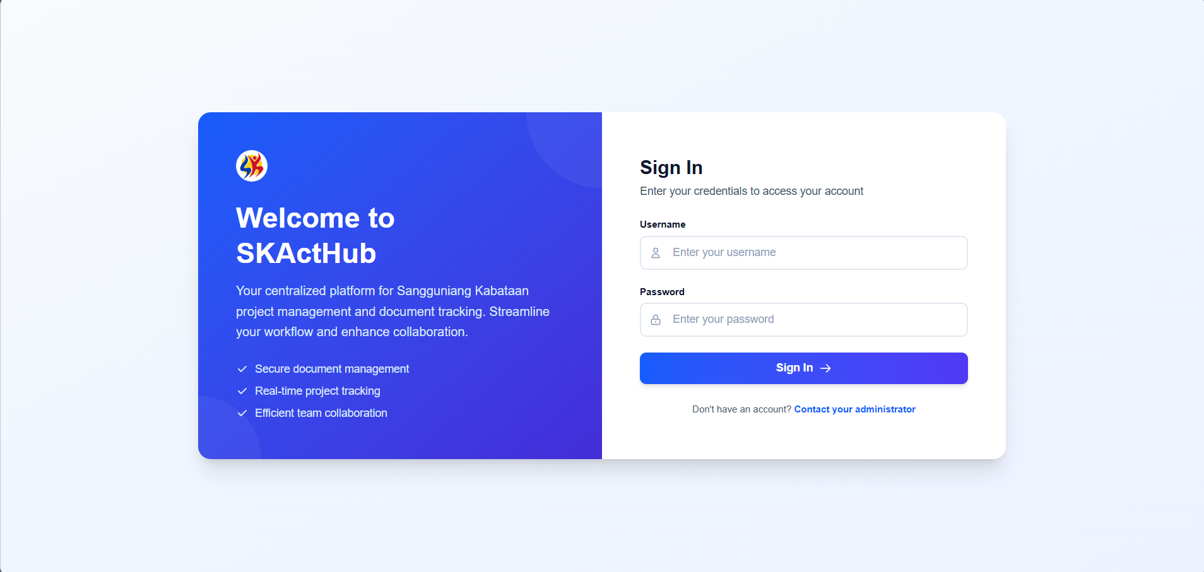

Admin User Interface :
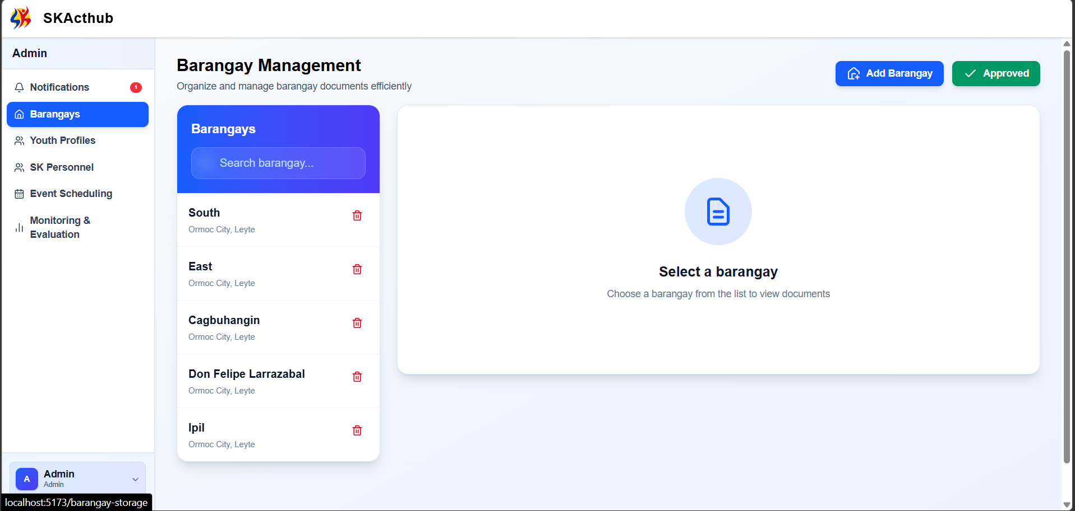
Sk Official User Interface :
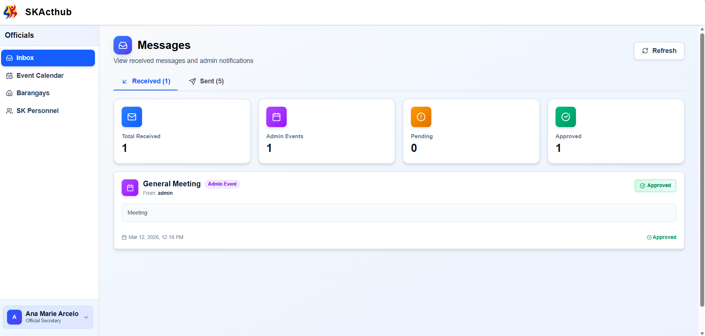

User Account Management :
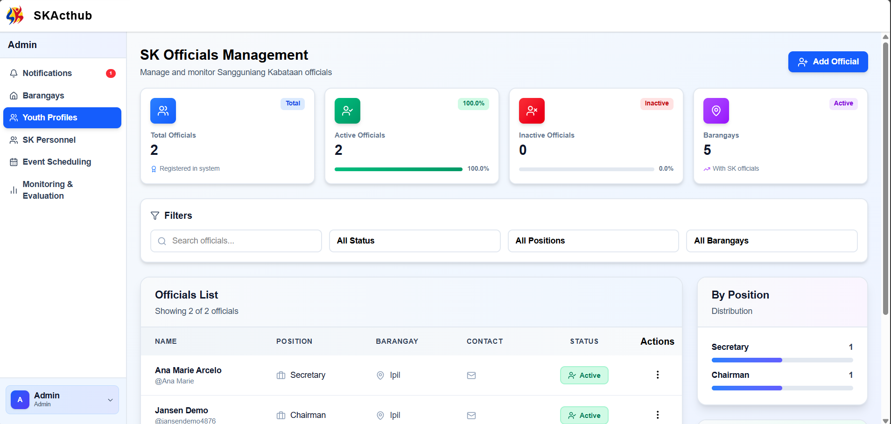
Document Upload Management:
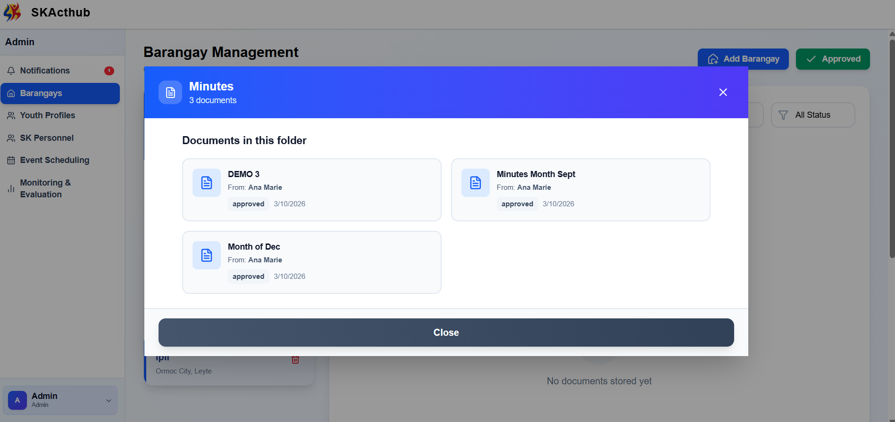

Document Categorization:
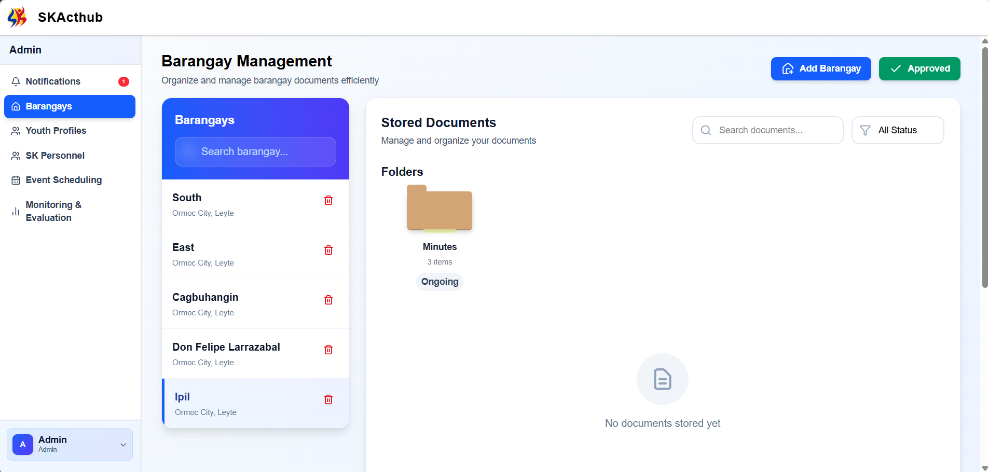

References:
Dizon, J. R., & Cruz, A. M.: Blockchain-Based Barangay Document Management System with OCR Data Extraction, IC-ITECHS Journal, 2023.
https://jurnal.ubhinus.ac.id/index.php/IC-ITECHS/article/view/1712
Reyes, M. A., & Dela Cruz, J. P.: Digitalizing Governance: A Transformation on the Processes of One Community in the Philippines, International Journal of Multidisciplinary Research and Analysis (IJMRA), 2020.
https://ijmra.in/v3i7/Doc/8.pdf
Santos, R. L., Mendoza, K. P., & Villanueva, J. T.: Contextualized Online Document Management System, Journal of Innovative Technology Convergence (JITC), 2021.
https://innocon.innotcs.org/index.php/jitc/article/view/55
Bautista, K. L., Ramos, J. D., & Ortega, S. M.: Web-Based Document Tracking System for Catanduanes State University, Journal of Information Systems Engineering and Management (JISEM), 2022.
https://www.jisem-journal.com/article/web-based-document-tracking-system
Triyana, A., & Fianty, M.: Web-Based Document Management Systems in Educational Institutions, International Journal of Science, Technology, and Management (IJSTM), 2023.
https://ijstm.inarah.co.id/index.php/ijstm/article/view/1106
Bizi, F., Ghazali, N., & Yunus, M.: Adoption of Electronic Document Management Systems in Organizations, Journal of Information and Knowledge Management (JIKM), 2025.
https://www.worldscientific.com/doi/10.1142/S021964922550003X
Awang Gani, R., Abd Kadir, M., Ab Rahman, S., & Mohd Yunus, N.: Electronic Document Management in an E-Government Environment, European Proceedings of Social and Behavioural Sciences, 2024.
https://www.europeanproceedings.com/article/10.15405/epsbs.2024.01.02
Anonymous: Factors Influencing Digital Adoption of Electronic Document Management Systems in the Public Sector, ScienceDirect, 2025.
https://www.sciencedirect.com/science/article/pii/S0740624X25000104
Lopez, A. M., & Mendoza, R. T.: EaseDocument System: A Web-Based Platform for Barangay Requesting Document, ResearchGate, 2023.
https://www.researchgate.net/search?q=EaseDocument%20Barangay
Garcia, P. R., Navarro, C. J., & Lim, S. A.: Docu-Go: The Development and Assessment of a Web-Based Barangay Document Requesting System, ResearchGate, 2022.
https://www.researchgate.net/search?q=Docu-Go%20Barangay
Innovatus Research Group: Implementing Document Management System Technology in Barangay Paligui, Apalit, Pampanga, Innovatus Research Publications, 2019.
https://www.researchgate.net/search?q=Barangay%20Document%20Management%20Paligui
De Vera, R. J.: E-RECORD: Web-Based Management System for Barangay Parian, Studocu, 2021.
https://www.studocu.com/ph/search?query=E-RECORD%20Barangay%20Parian
Braude, Eric J.: Software Engineering: An Object-Oriented Perspective, 5th Edition, McGraw-Hill, 2001, ISBN 0-07-365578-3.
https://www.mheducation.com/highered/product/software-engineering-braude/M9780073655780.html
Venners, Bill.: The Demand for Software Quality, Artima Software Inc., August 12, 2005.
http://www.artima.com/intv/serious.html

